OUTS
We collected donated items and service time this week:
St. George Church, Baton Rouge, Joyce Jackson
(10 tricycle handlebar cover sets toward Playground Initiative)

Wal-Mart Foundation and the University of Alabama through
Catholic Charities of Diocese of Baton Rouge
(Donations of bleach, toilet paper, paper towels, hygiene kits and water delivered by Jeff Wagner, Jack Canizaro, Cathy Shaw and Clay Aguillard)

St. Cecilia Catholic Church, Houston, Texas
($300.00 toward Flood relief)

Claire Langlois and Emily Mistrzak, Covalent Logic, Baton Rouge
(Shadow Box of new website on display in lobby of new website)

Miss Humphrey, Baton Rouge
(Baby Girl gift basket for parent of student, card signed by RSG Wolfpack)
Important Dates:
September | Praline Sales continue, $2.00 donation
5 | Labor Day Holiday-NO SCHOOL
6 | School Resumes, ACT Aspire Window Continues
7-8 | Pre-K walkthrough of church, 9:00 am
8 | Open House, 5:00 pm, Mentoring Program begins
9 | First School Mass in St. Gerard Majella Church, 9:00 am
9 | Scholastic Book Fair Opens
9 | Ms. Brown’s Birthday

Song of the Week : (Kirk Franklin) I Smile
“Today’s a new day…but tell me where are my blue skies
I almost gave up but a power that I can’t explain, (that Holy Ghost power)
fell from heavan like a shower now.
When I think of how much better I’m gonna be when this over, I smile.
Even though I hurt see I smile, I know God is working so I smile, Even though I been here for a while,
I smile, Alleluia
Smile, it is so hard to look up when up you been down, sure would hate to see you give up now
God’s people you look so much better when you smile

Scripture of the Week: Psalm 106:1-5

Inspirational Pictures: THANK YOU FOR ALL THAT YOU DO FOR STUDENTS AND FAMILIES!
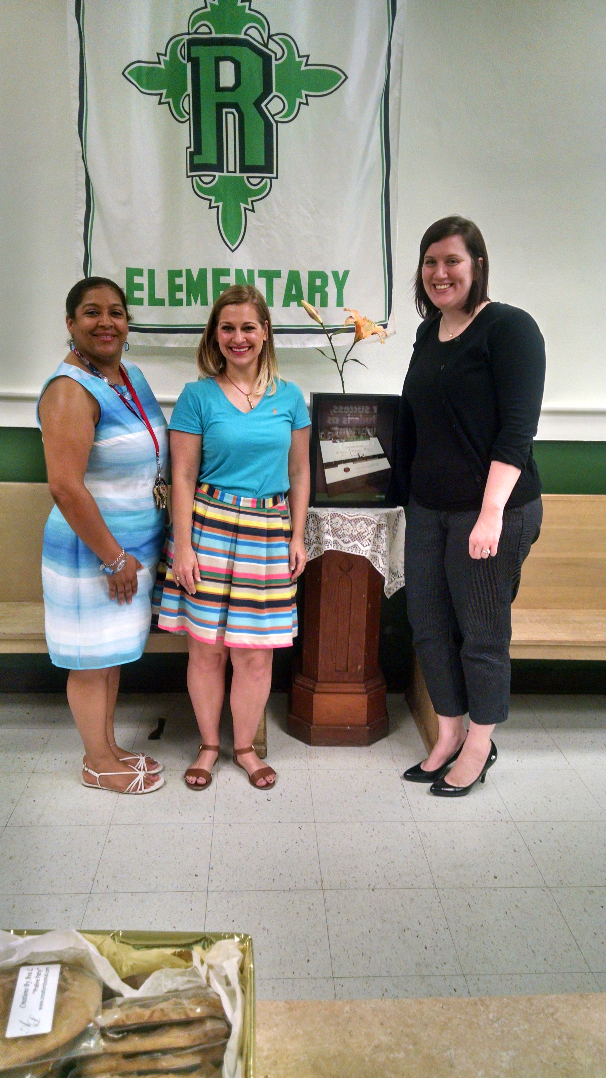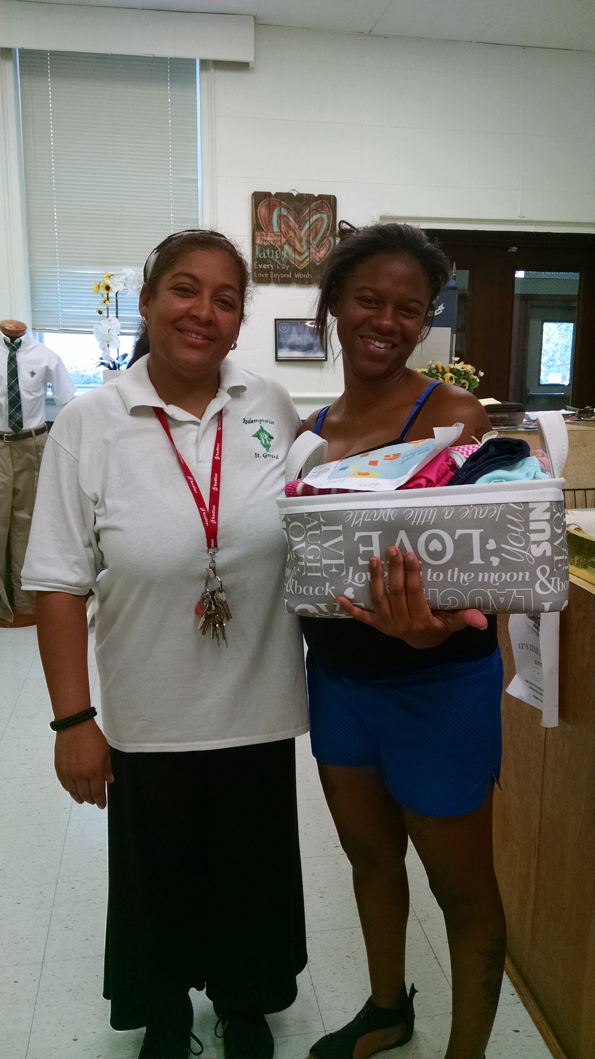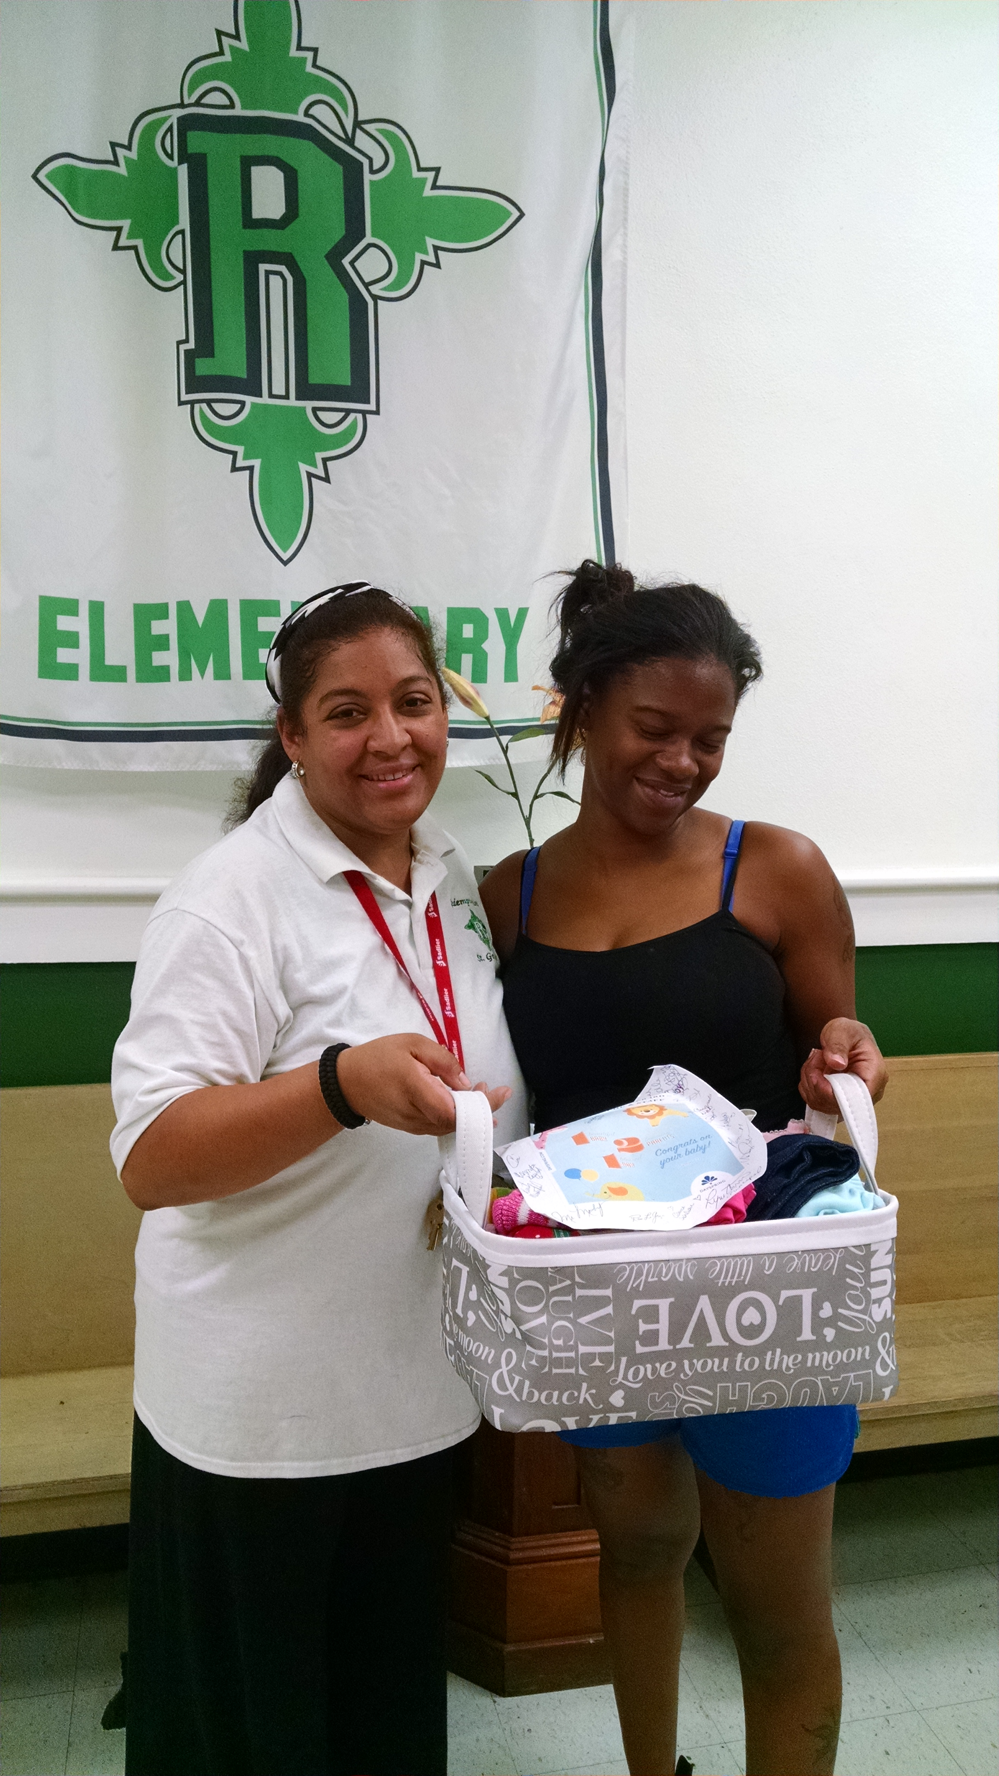

Middle School science classes are in need of used glass jars for rock candy project.
Please bring those glass jars to Ms. Johnson and allow students to turn in those glass jars to her.

