OUTS
We collected donated items and service time this week:

St. George Church, Baton Rouge, Joyce and Jack Jackson
(Freshly washed and folded uniform shirts, $610.00 for flood aid-$310 used for $10 Tony’s gift cards to faculty, staff and friends who attended meeting on Friday and worked the campus cleanup on Saturday or Sunday)

Hamza and Darren, grandsons of Cheryl Hawkins
(Helped move items in PD/mailroom and move used uniforms to Finance Office)

Welcome to the Wolf Pack Family

Caressa Lathan, 1st grade Substitute for Yolanda Williams

Important Dates:
August
22 | Faculty Handbook signed contract due, 12:00pm in my mailbox
23 | Principal and Pastor Retreat
24 | Open House, 5:30 – 7:30pm
27 | LSU Concessions Training, 10:30 am, Stadium Gate 1
31 | LSU Concession Dinner Meeting, 6:30pm, Faculty Club
September
1 | ACT Aspire Window Opens

Song of the Week (SFX 8:00am service) On the Battlefield for my Lord
“I was alone and idle, I was a sinner too,
I heard a voice from heaven say there is work to do,
I took the Master's hand, And I joined the Christian band,
I'm on the battlefield for my Lord.”

Scripture of the Week: Rev 22:12-13

Inspirational Pictures:

Keegan helping fill sandbags…”Let’s all Dig Deep within to Help the RSG Family community”

Cole testing equipment for safety/functionality on the water damaged gym floor…”Roll with It Team”

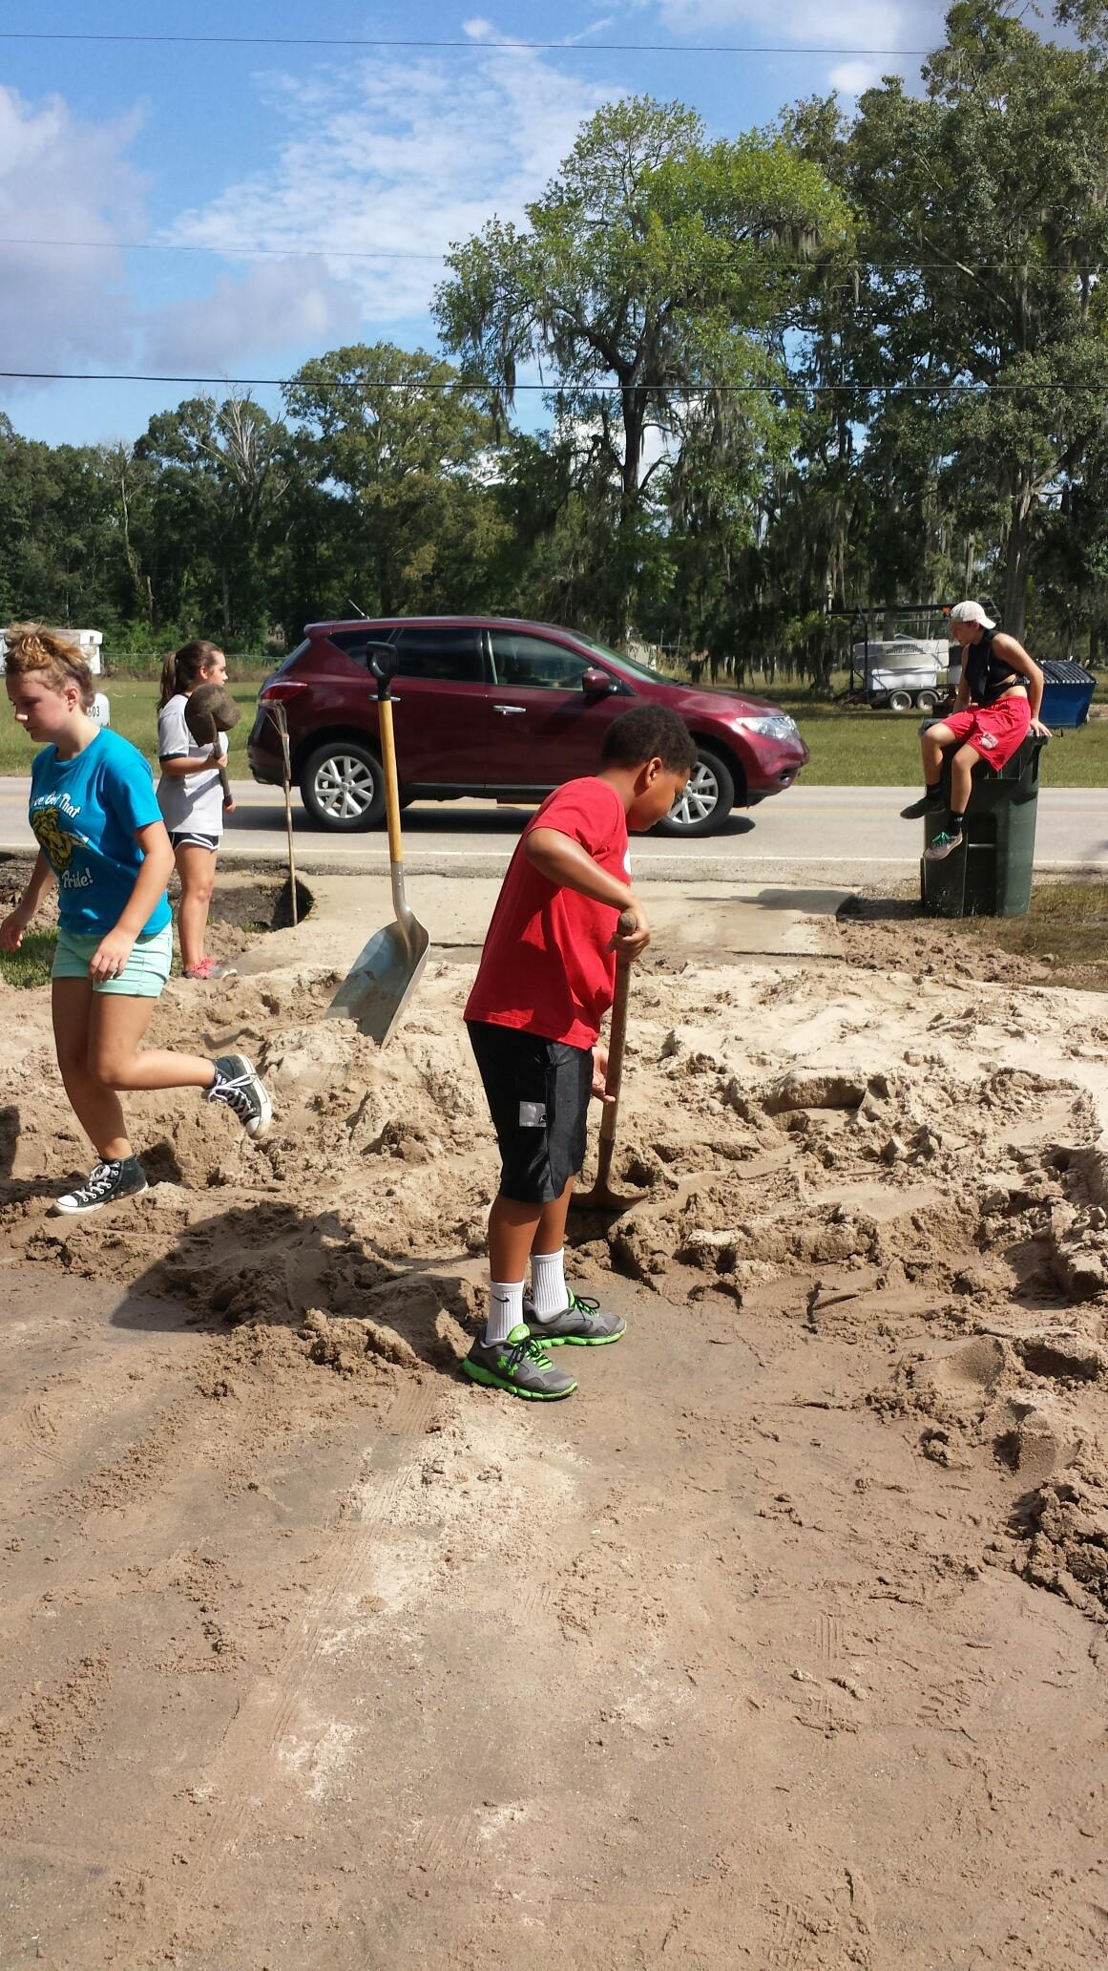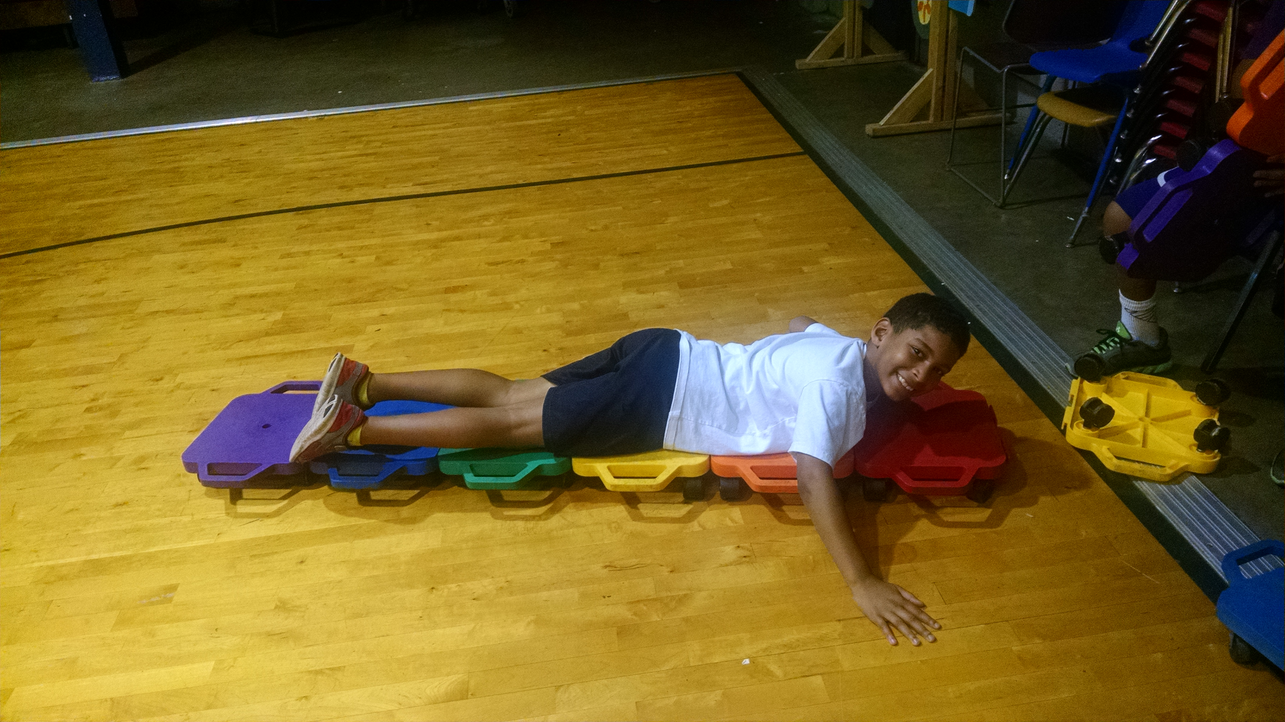

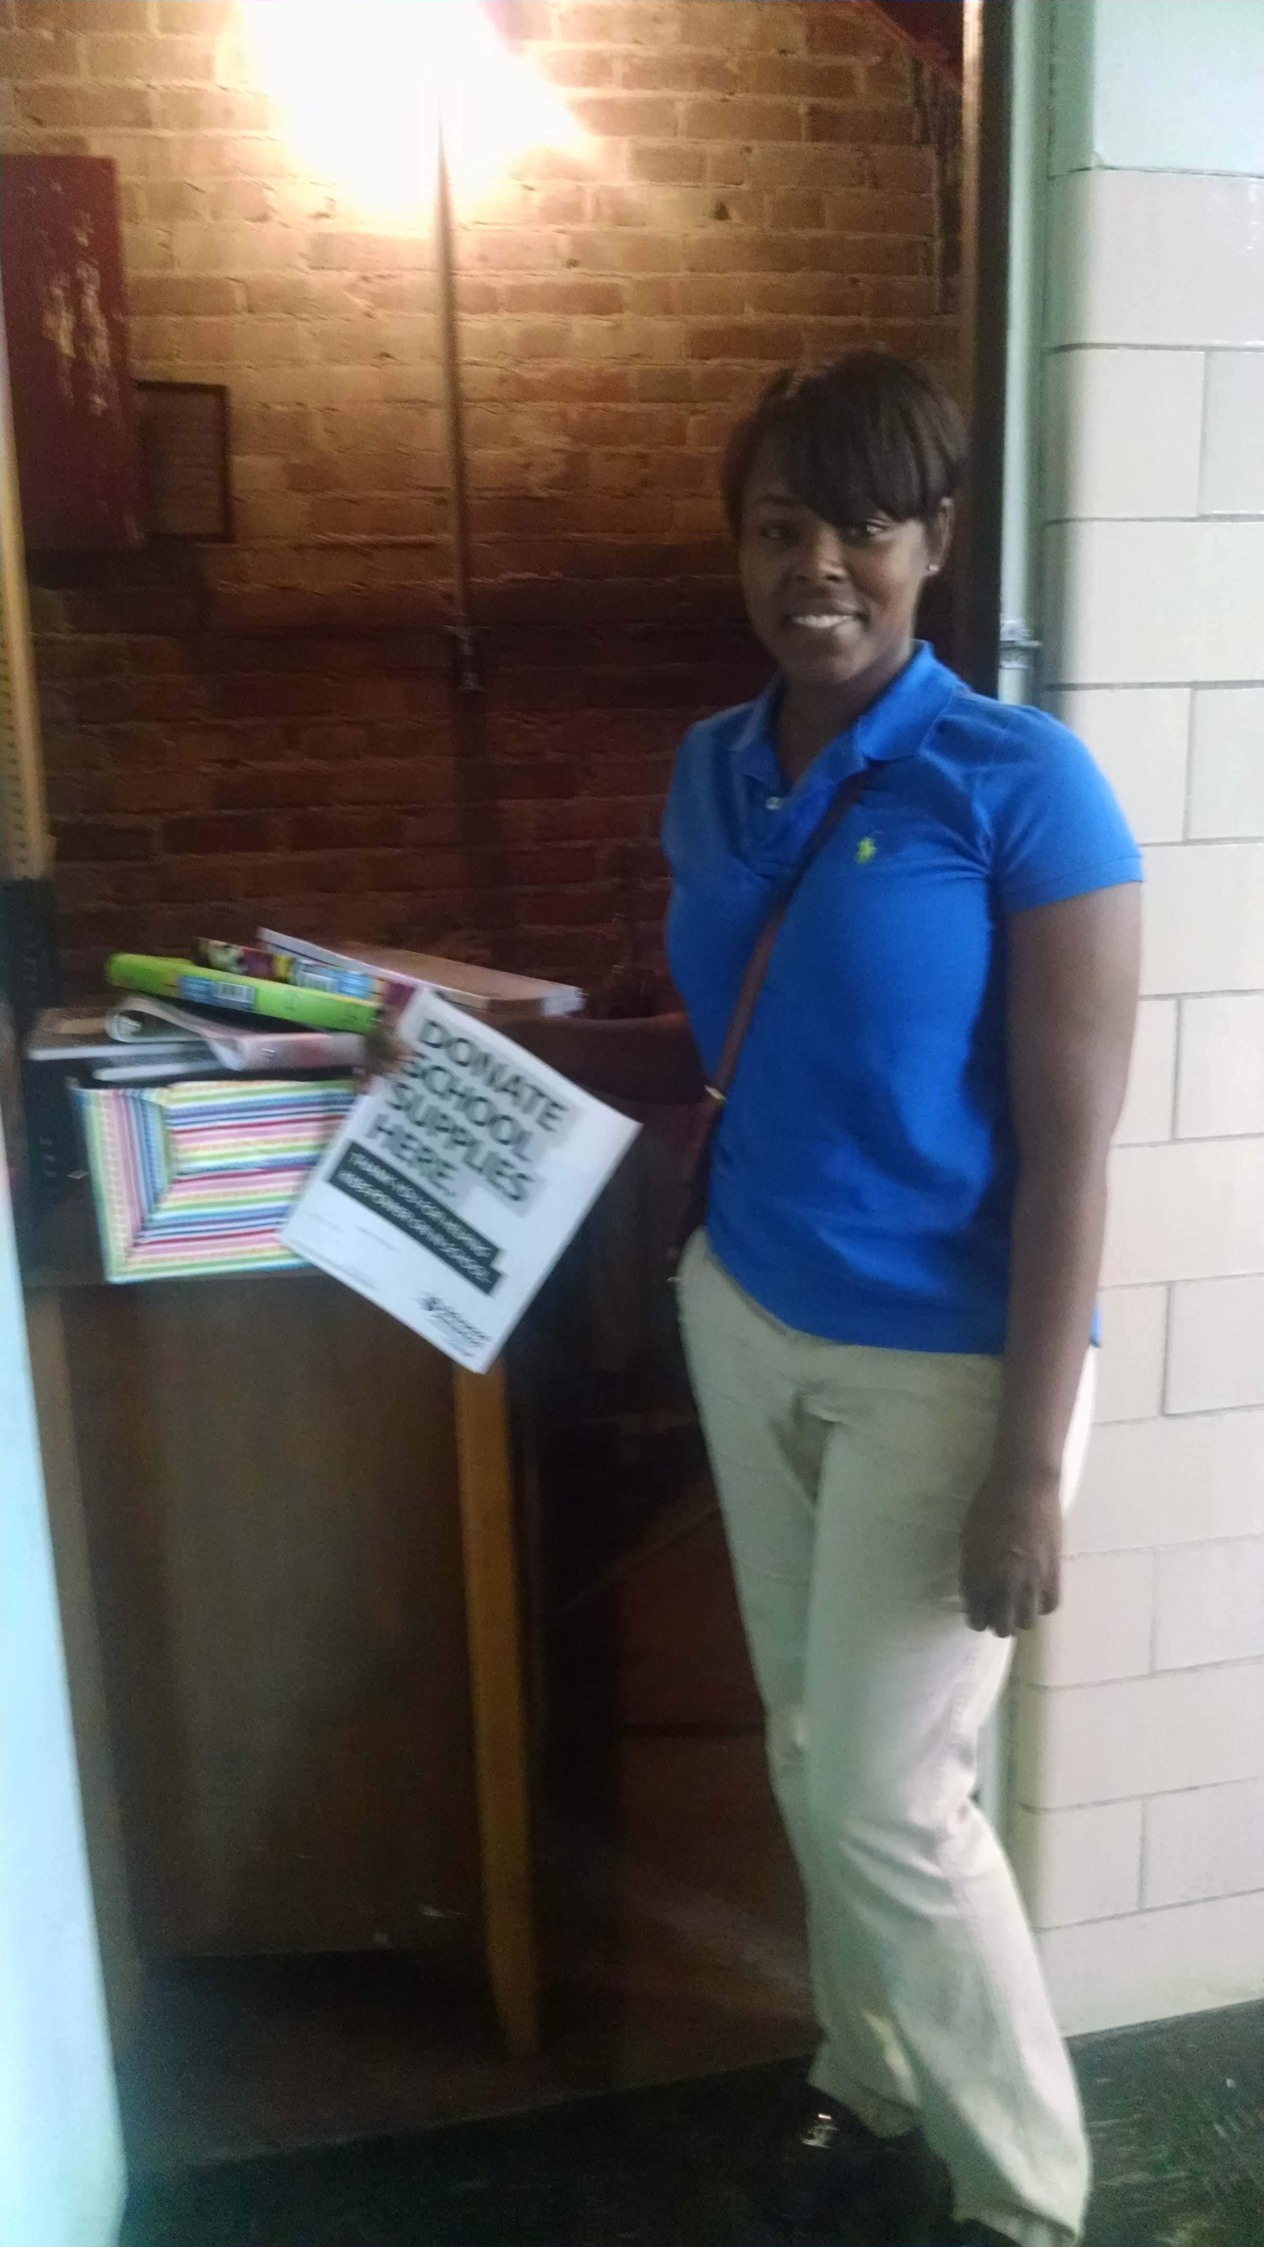

Ma
Ms. Martina Cherry, parent volunteer, with school supply donations from her job.

