OUTS
We collected donated items and service time last week:
Dr. Keith Courville, A+Pel and Two Men and a Truck
(Teaching resources through national connections)

Mr. Russell Stokes
($50.00 toward Playground Initiative)

J. Dickerson, L. Collins, S. Boatner, S. Calhoun, L. Davis
(WolfMart volunteer time and energy)

Don and Mary Keller, New Orleans, LA
(Reading and Library Resource Donations)

Cheering4Books, Ms. Betsy Wilson, Prairieville, Louisiana
(volunteer to read to a class, e-mail me if interested!)

eWalk Team, SLC, Holy Family, St. Francis Xavier, CSO
(classroom observations)
October | Redemptorist Sock Sales, $5.00 donation
10 | Welcome Mrs. Amy Christen, Ruth Oliver, Admin. On Call
11 | Principal Carmouche, Meeting from 10:00am-3:00pm
12 | Brother Clement in PreK and K, 9:15 & 9:45
12 | Submit final HR voting ballots to front office
14 | First 9-week Report Cards go Home
14 | Prayer Service, Feast Day of St. Gerard Majella
18 | SBLC meetings with EBR school personnel
18 | Faculty Meeting, 3:00pm, Cafeteria
20 | Principal Carmouche, Meeting from 10:00am-3:00pm

Song of the Week: (MercyMe) “I Can Only Imagine”
“I can only imagine what it will be like, when I walk by your side. I can only imagine what my eyes will see when your face is before me. I can only imagine. Surrounded by your glory, what my heart will fill, will I dance for you Jesus in awe of you be still, I will stand in your presence or to my knees will I fall. Will I sing Alleluia, will I be able to speak at all. I can only imagine, I can only imagine when that day comes and I find myself standing in the Son. I can only imagine, when or what I will do is forever, forever worship you.”

Scripture of the Week: 1 Thessalonian 5:18

Inspirational Pictures: THANK YOU FOR ALL THAT YOU DO FOR STUDENTS AND FAMILIES!
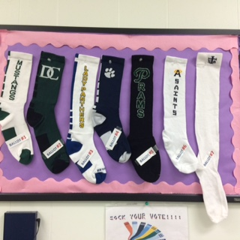
Share the right to vote with students. 7 sock designs and styles!
Voting extended through Wednesday, October 12.

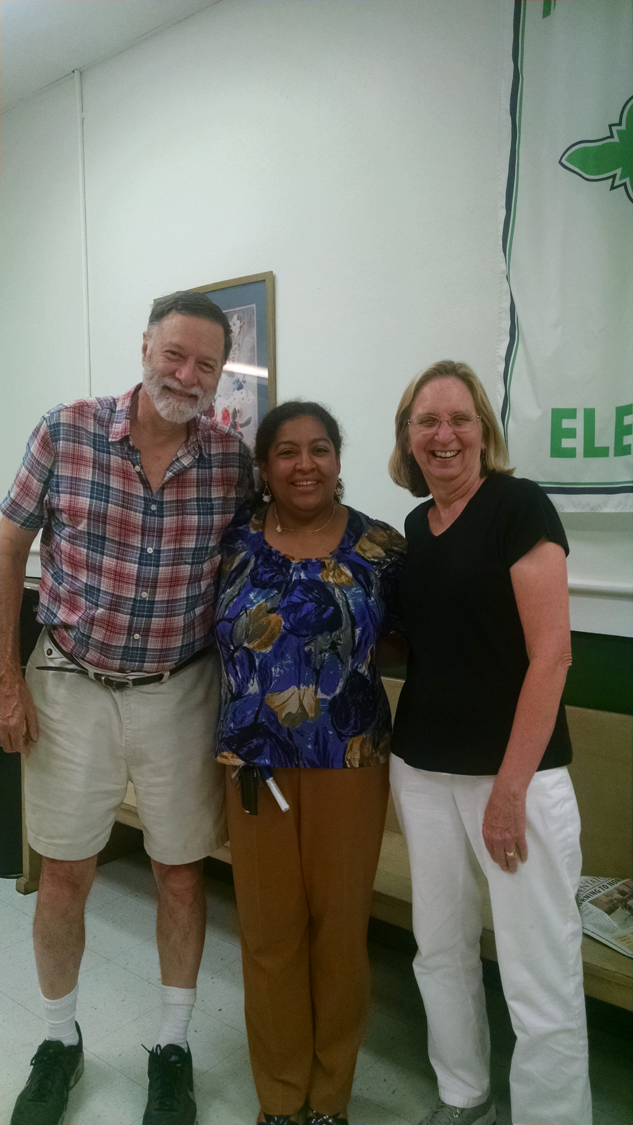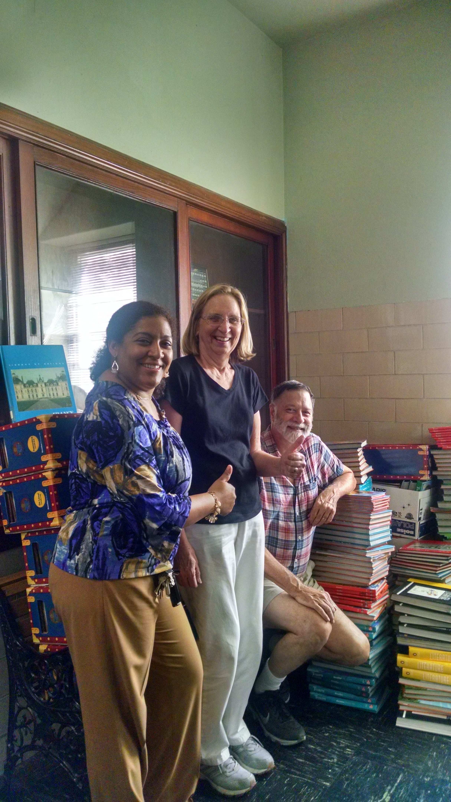Mr. Don Keller & Mrs. Mary Keller donate resources

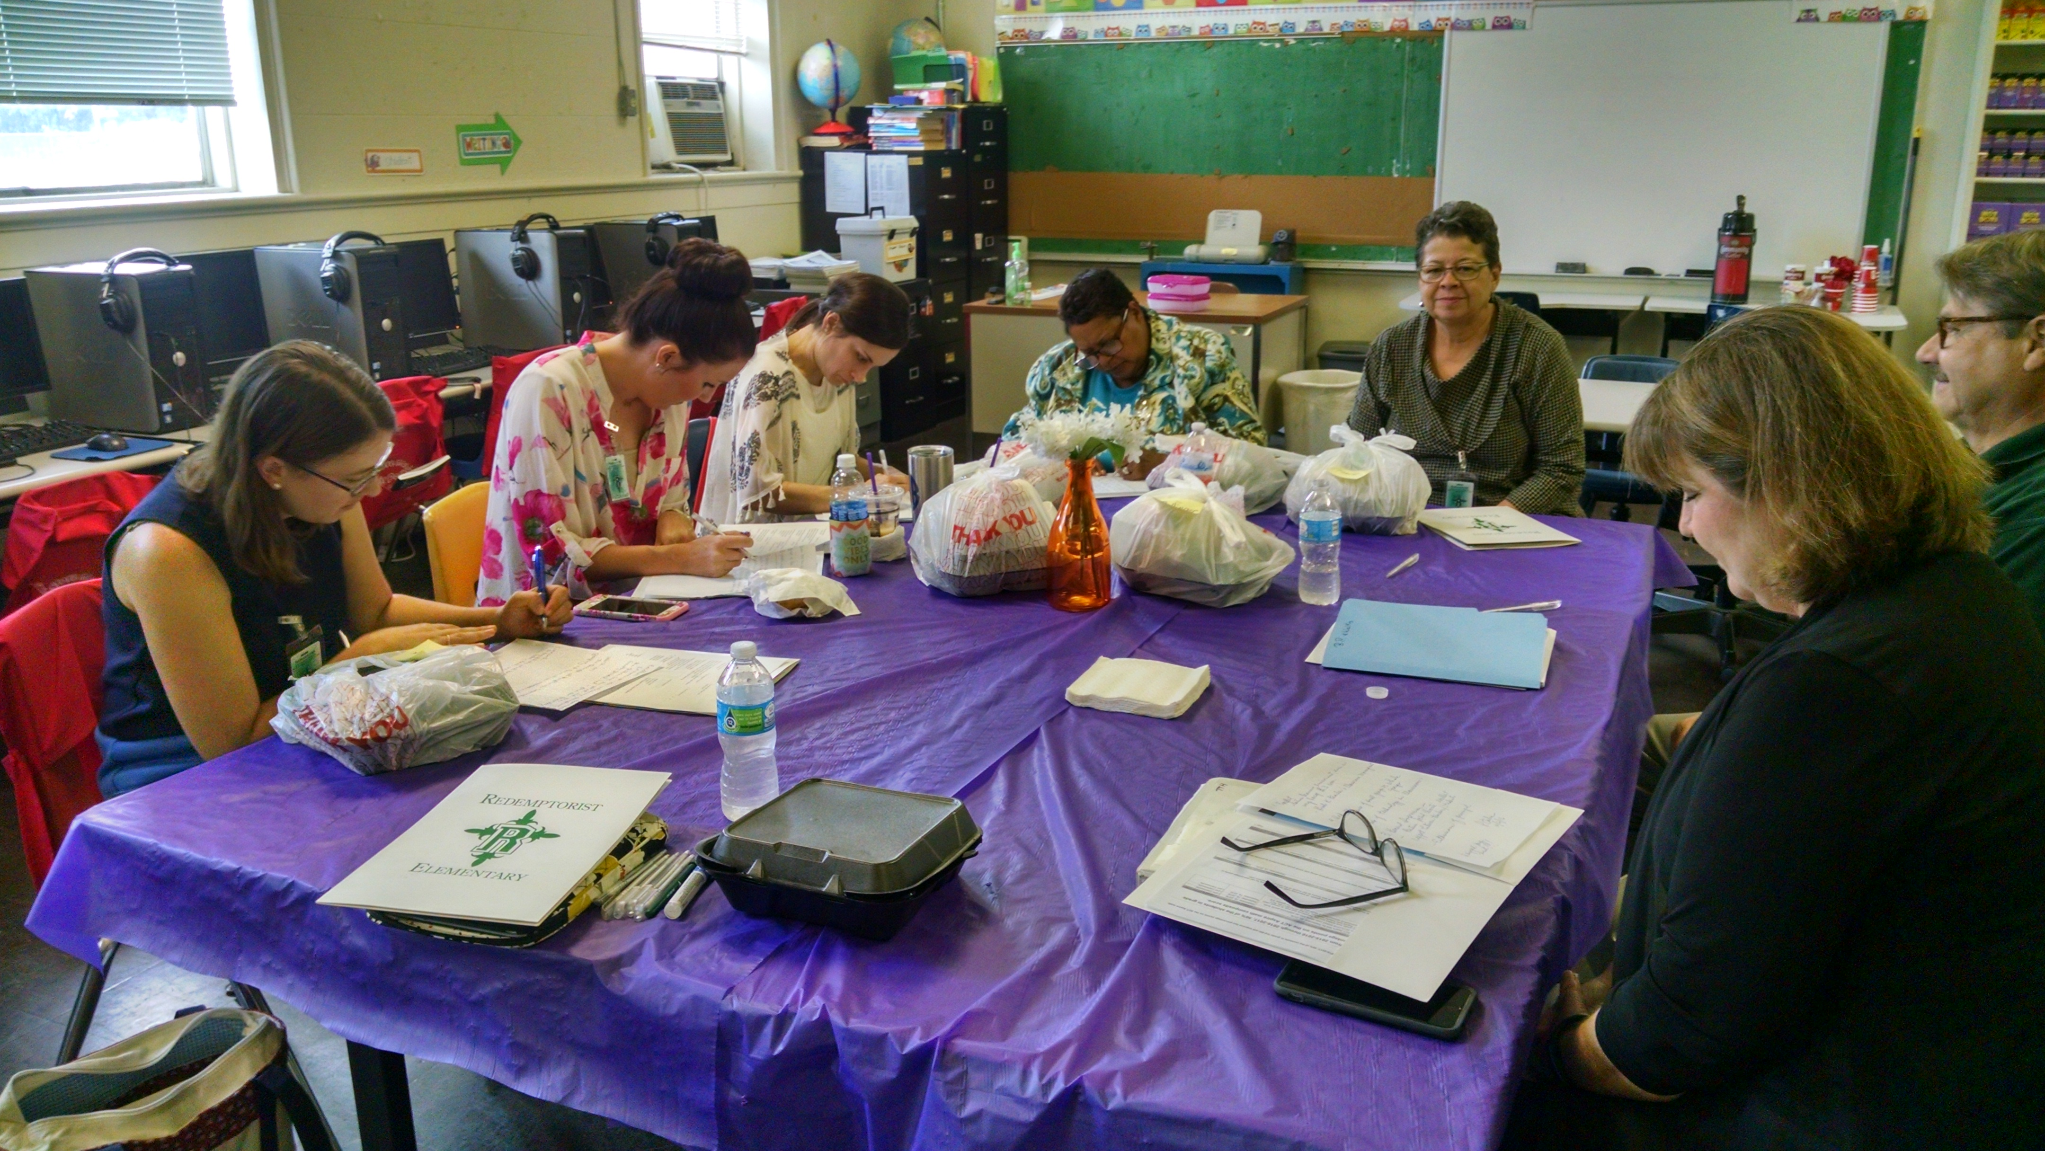 eWalk Team Members on their Visit

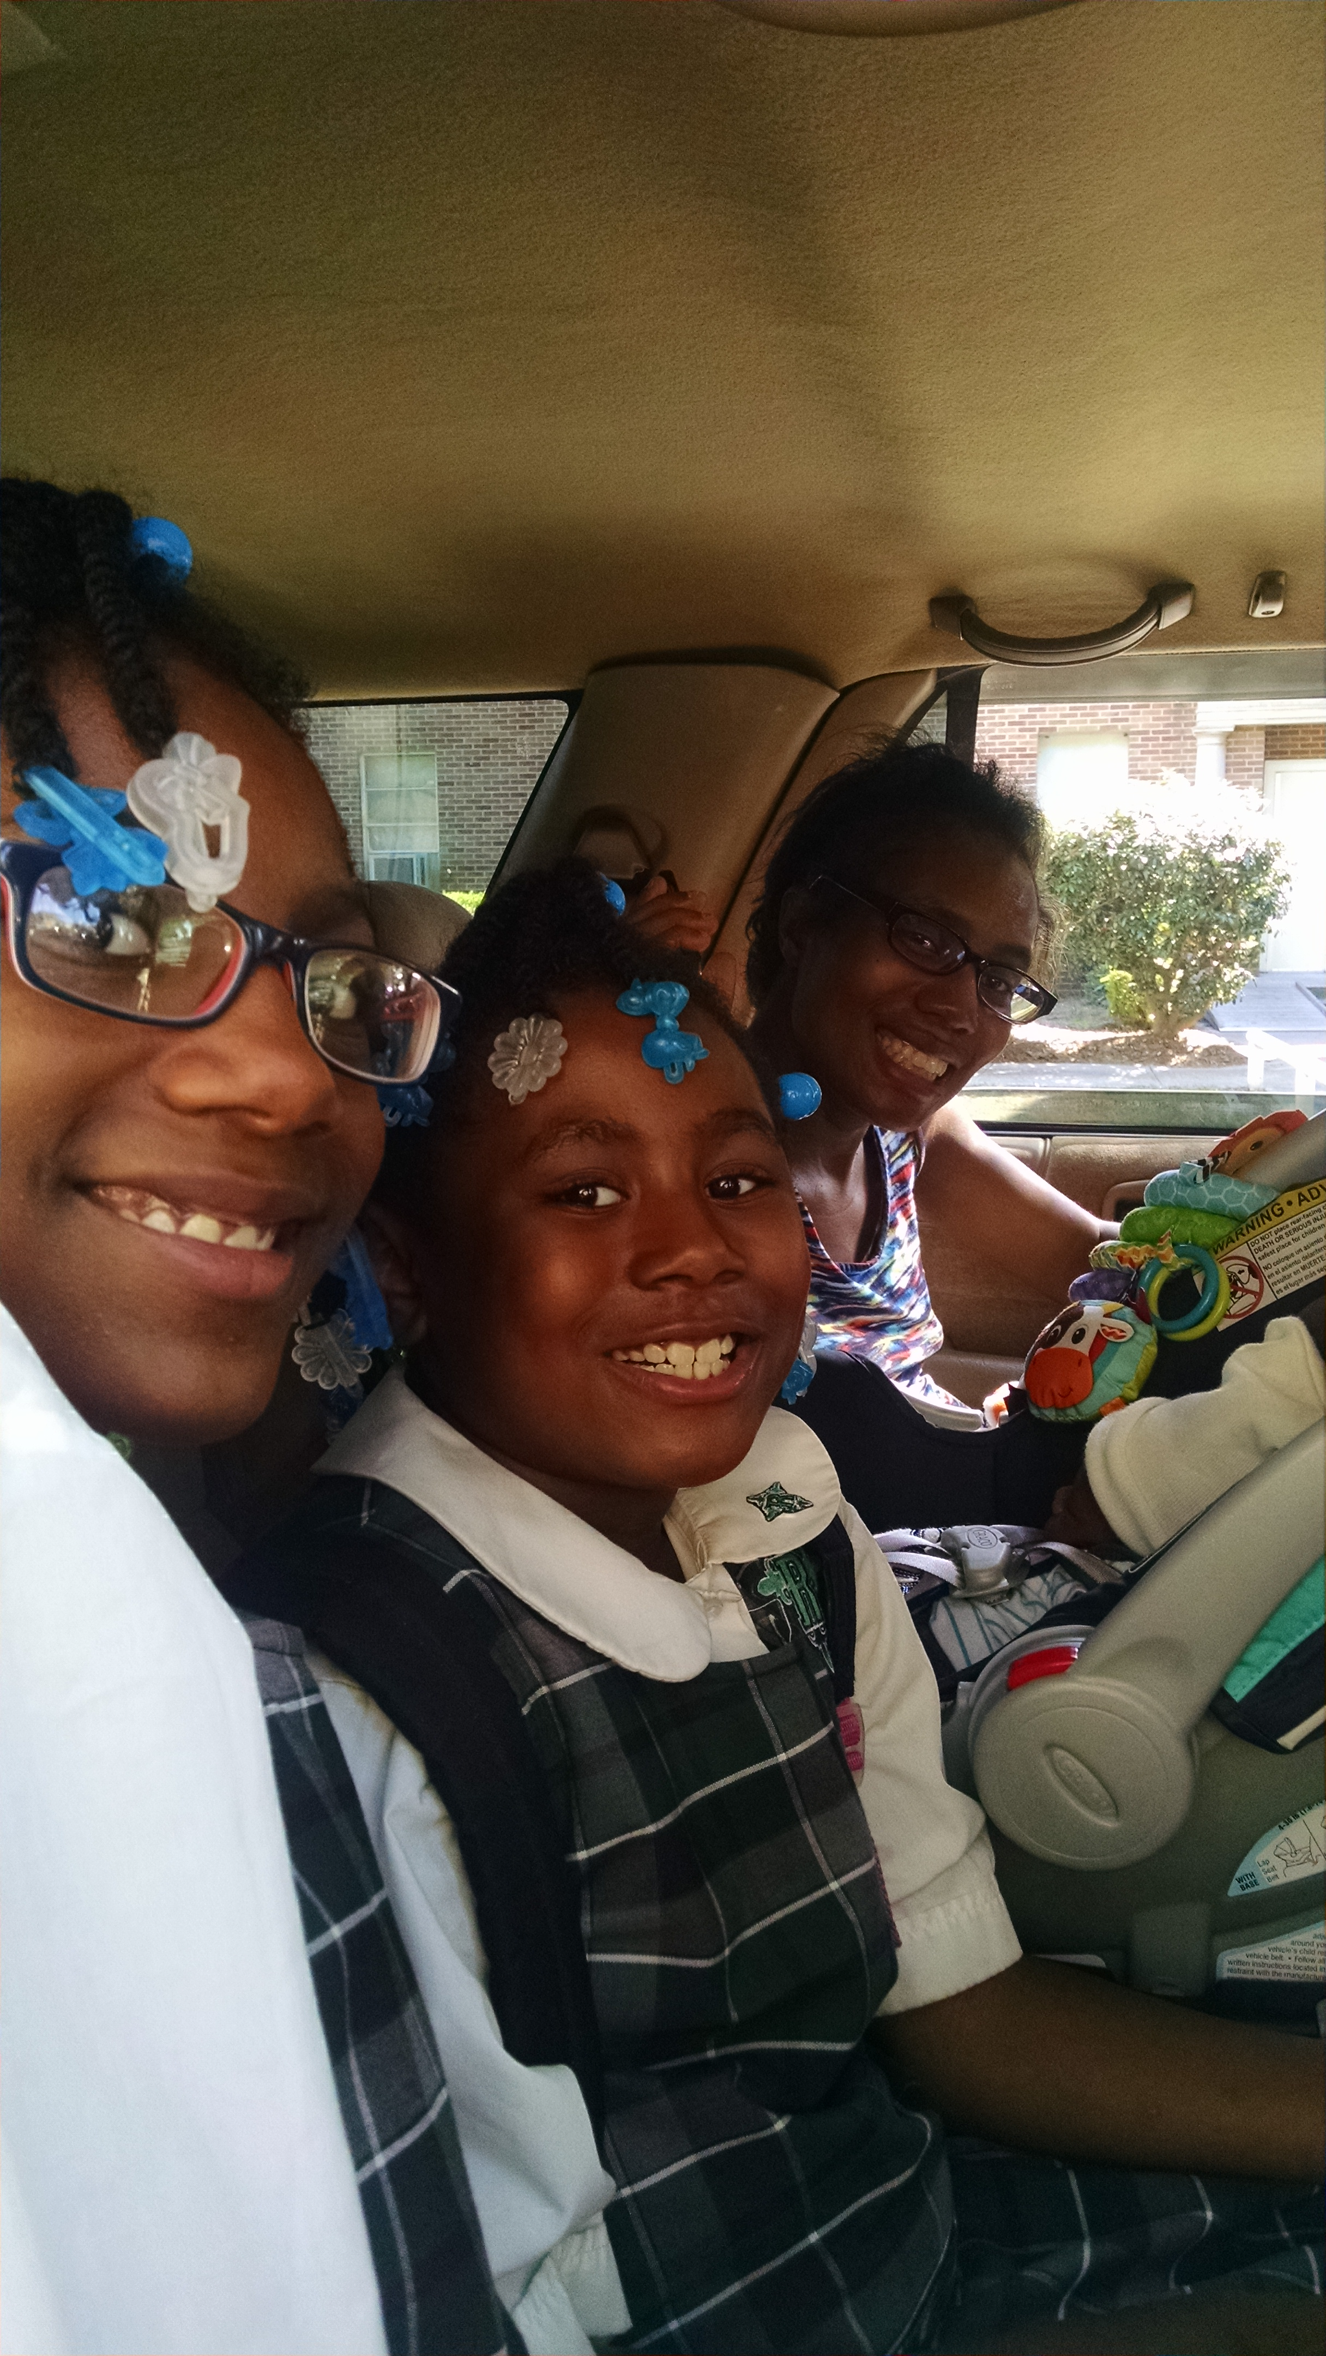
Keenan Williams, future Wolf, with big sisters and parents. Mom was in labor in my office!

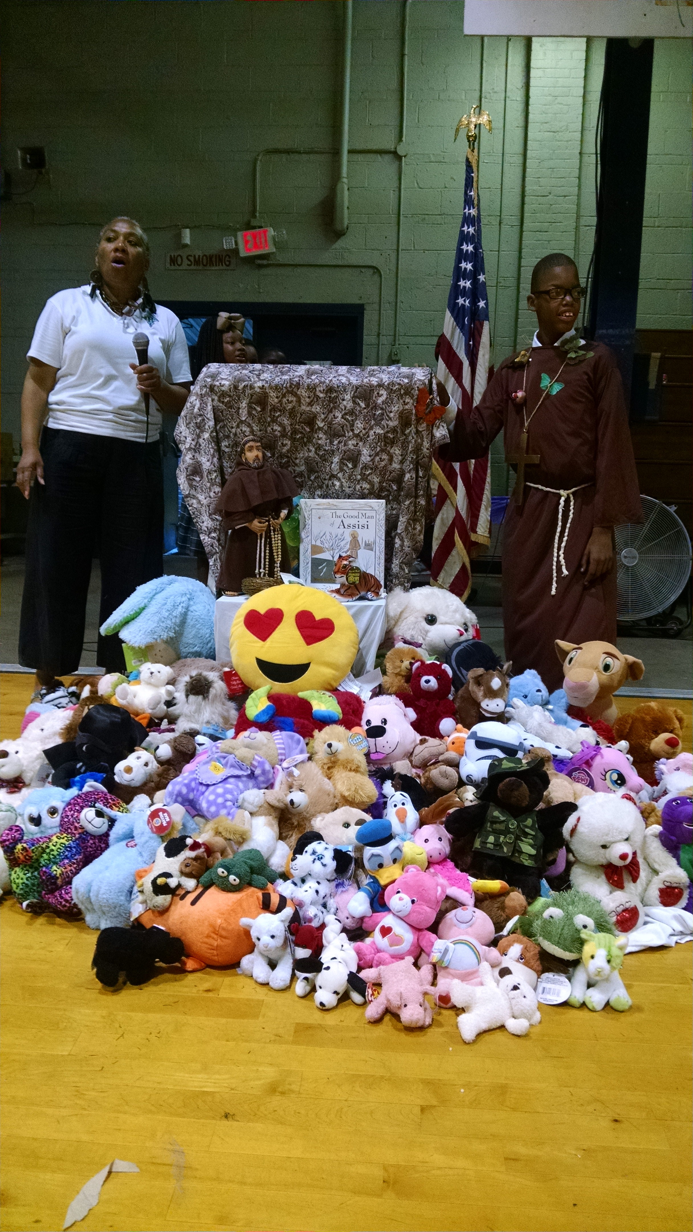Ms.Will with Rodney Jones, as St. Francis of Assisi.

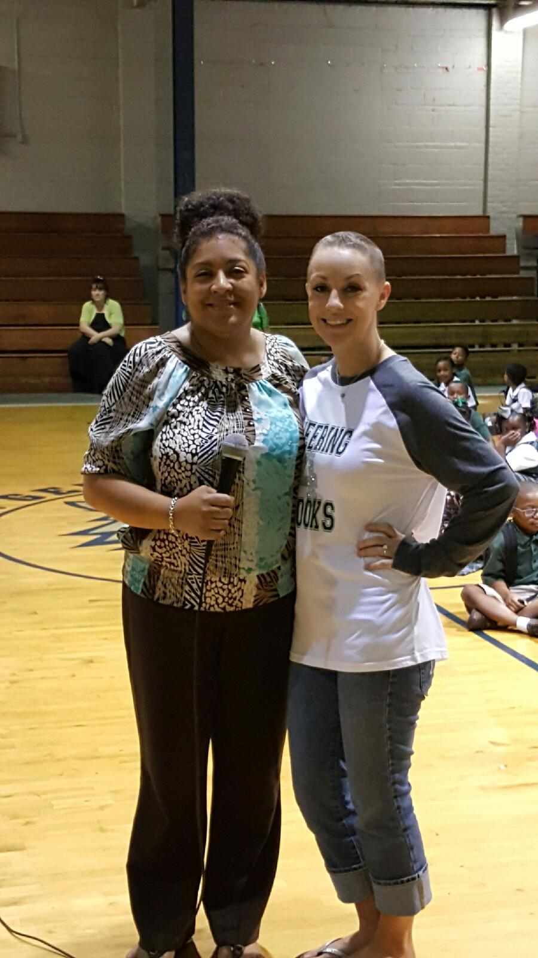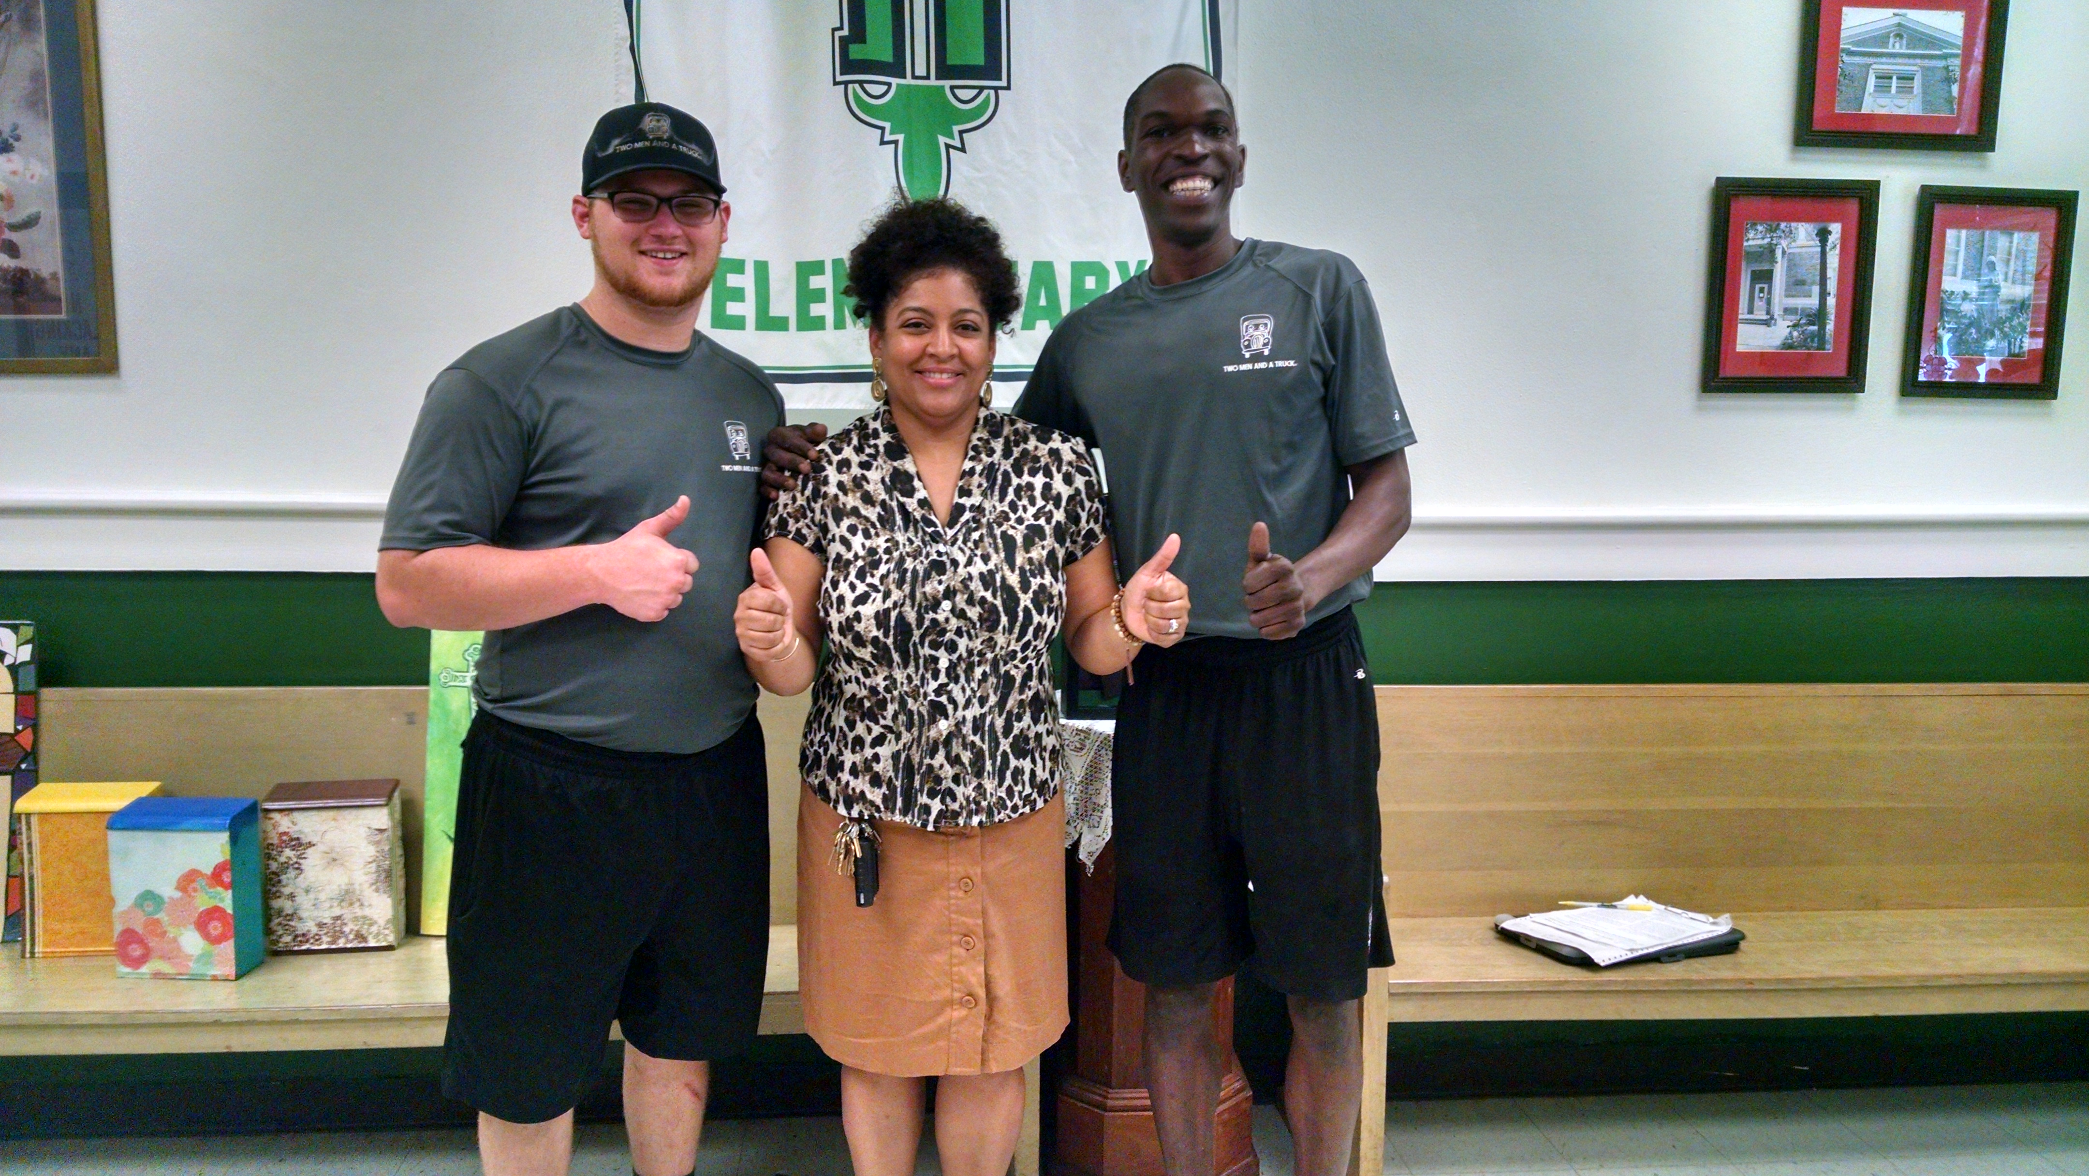
SBetsy Wilson poses with me. Two Men and a Truck deliver resources from Dr. Courville’s friends.
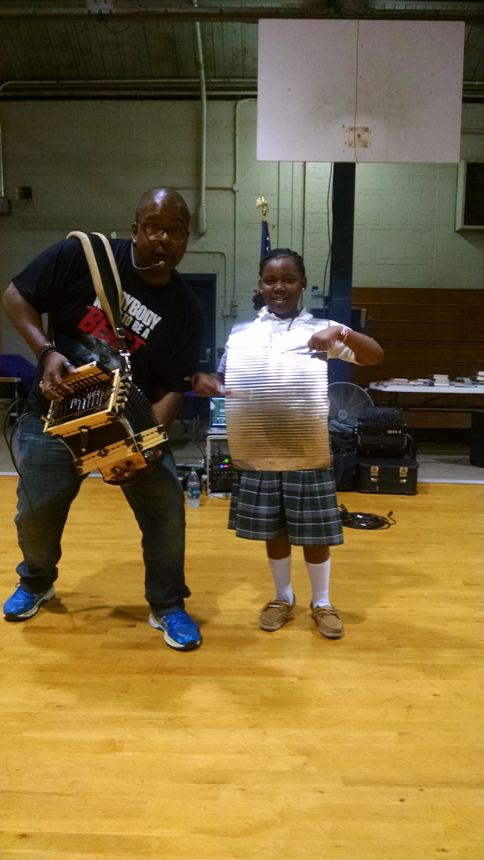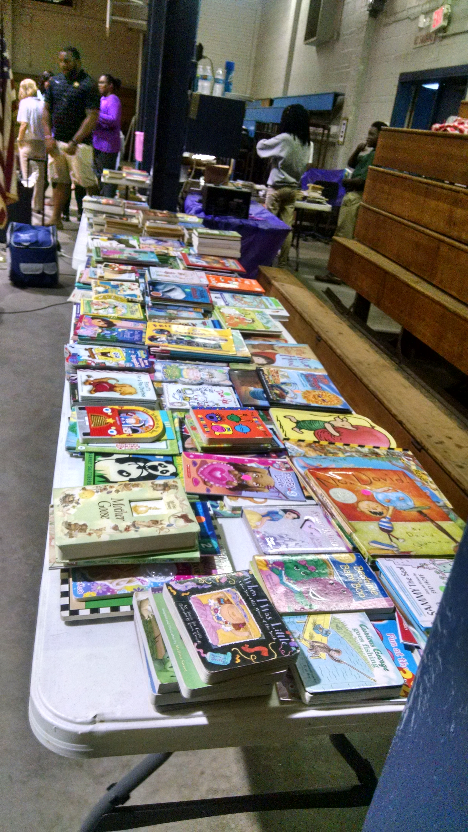
Sean performs and books galore were distributed.

