OUTS
We collected donated items and service time this week:

Chuck Saia, Backyard Adventures
(Labor charges for playground installation)

New 8th grader to start Monday
(One new students begins)

Ruth Oliver
(Progress Report Template)

Important Dates:
September | Redemptorist Sock Sales, $5.00 donation
26 | ACT Aspire Interim Continues through Sept. 30
26-29 | Kids’ Orchestra, 3:30-5:30, Claiborne ES
27 | Speech Services begin by Ashley Hatfield, Title 1 room
 | Double Dress Down Day, $2.00
30 | Employee Profiles and School File Updates Due
30 | 2nd Mass in the church
October
4 | Faculty Meeting, 3:00pm, Computer Lab
5 | Discovery Walk by Instructional Visitors
6 | Musical Performance by Sean Ardoin, 7:20am Assembly
7 | Flood Make-Up Day #1

iGive Catholic Campaign: Registration is now open for the donation program View iGive and prepare for the giving campaign November 29-30. Begin sharing with your families and spread the word! Questions? Contact tabshire@diobr.org

Song of the Week: (Donnie McClurkin) “Wait on the Lord”
“Sometimes in life you’ll find that you get in a hurry, but when you have assurance, no need to worry. You can wait, wait, wait on the Lord and you’ll see will He’ll always keep His word. Trust, just trust on Him; don’t be dismayed. Patience in time of trouble, trust and believe Him. And everything God’s promised, you will receive it.”

Scripture of the Week: Eccl 11:9-12:8

Inspirational Pictures: THANK YOU FOR ALL THAT YOU DO FOR STUDENTS AND FAMILIES!

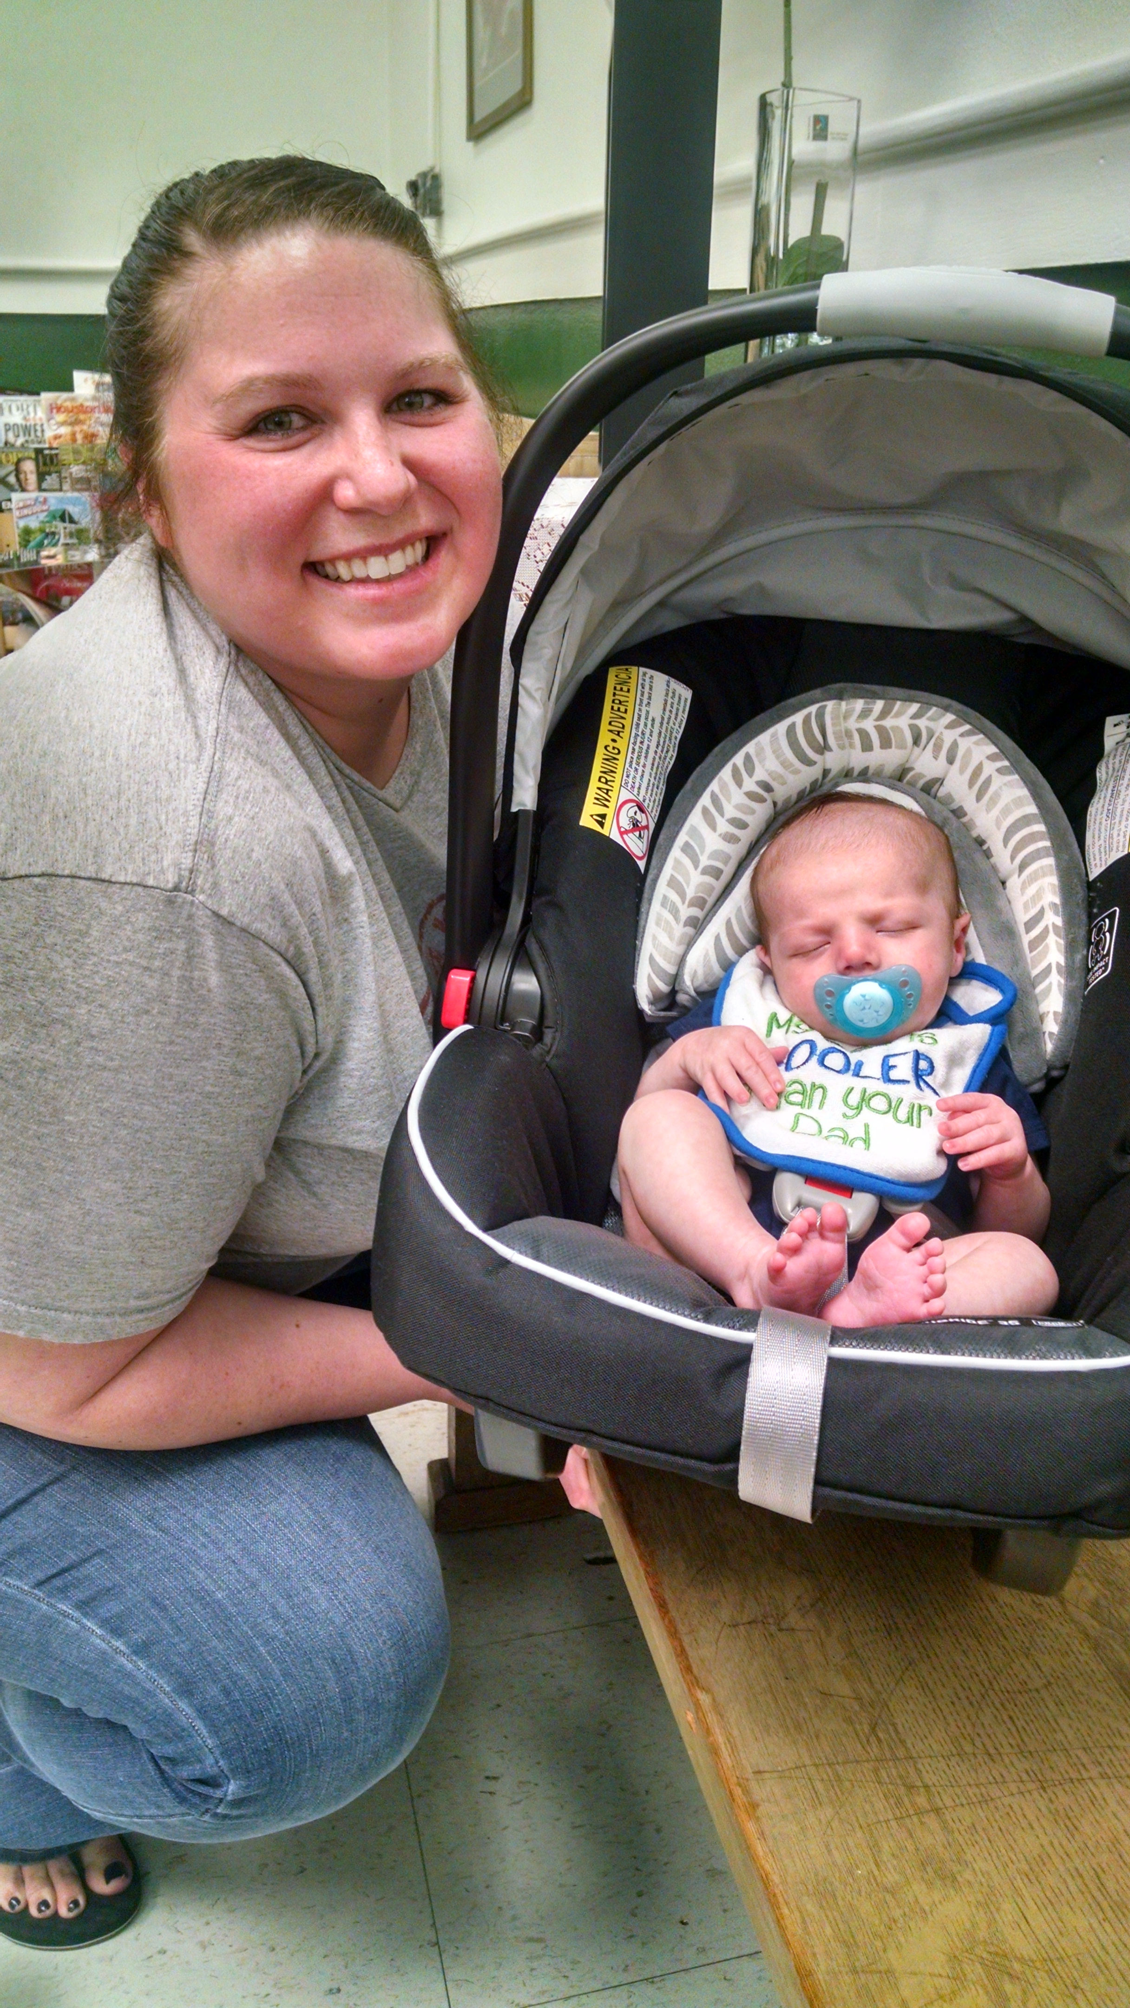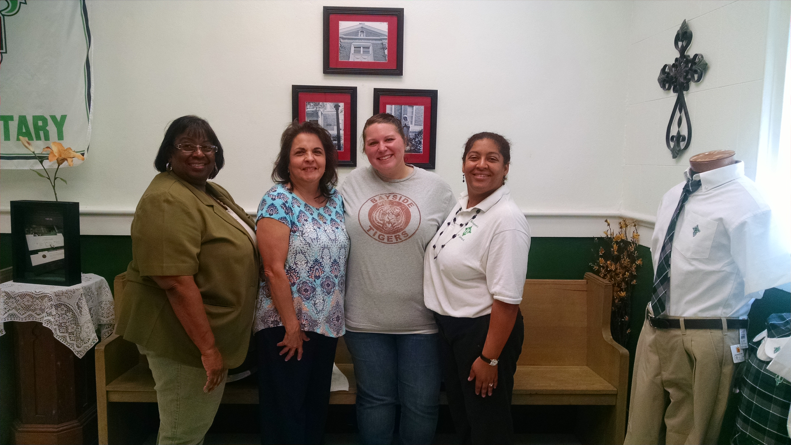

Annie Dronet resigns to stay Front Office and Administration say goodbye & good luck.
home with 1st son, Christian.

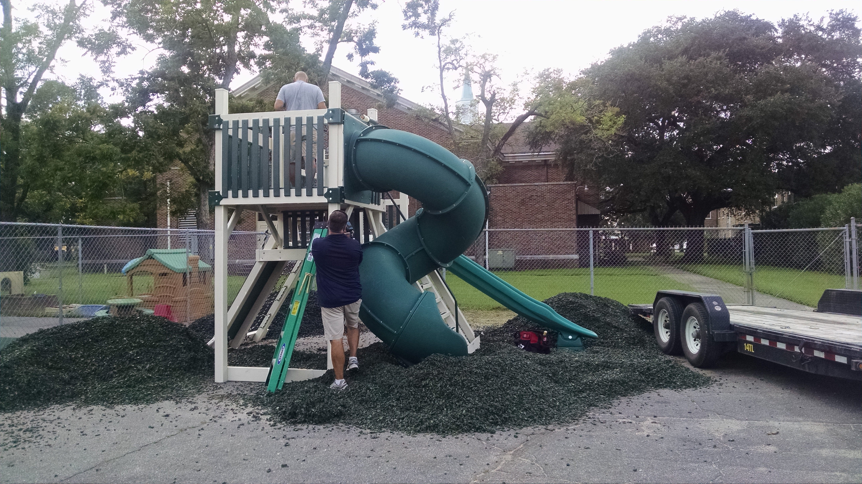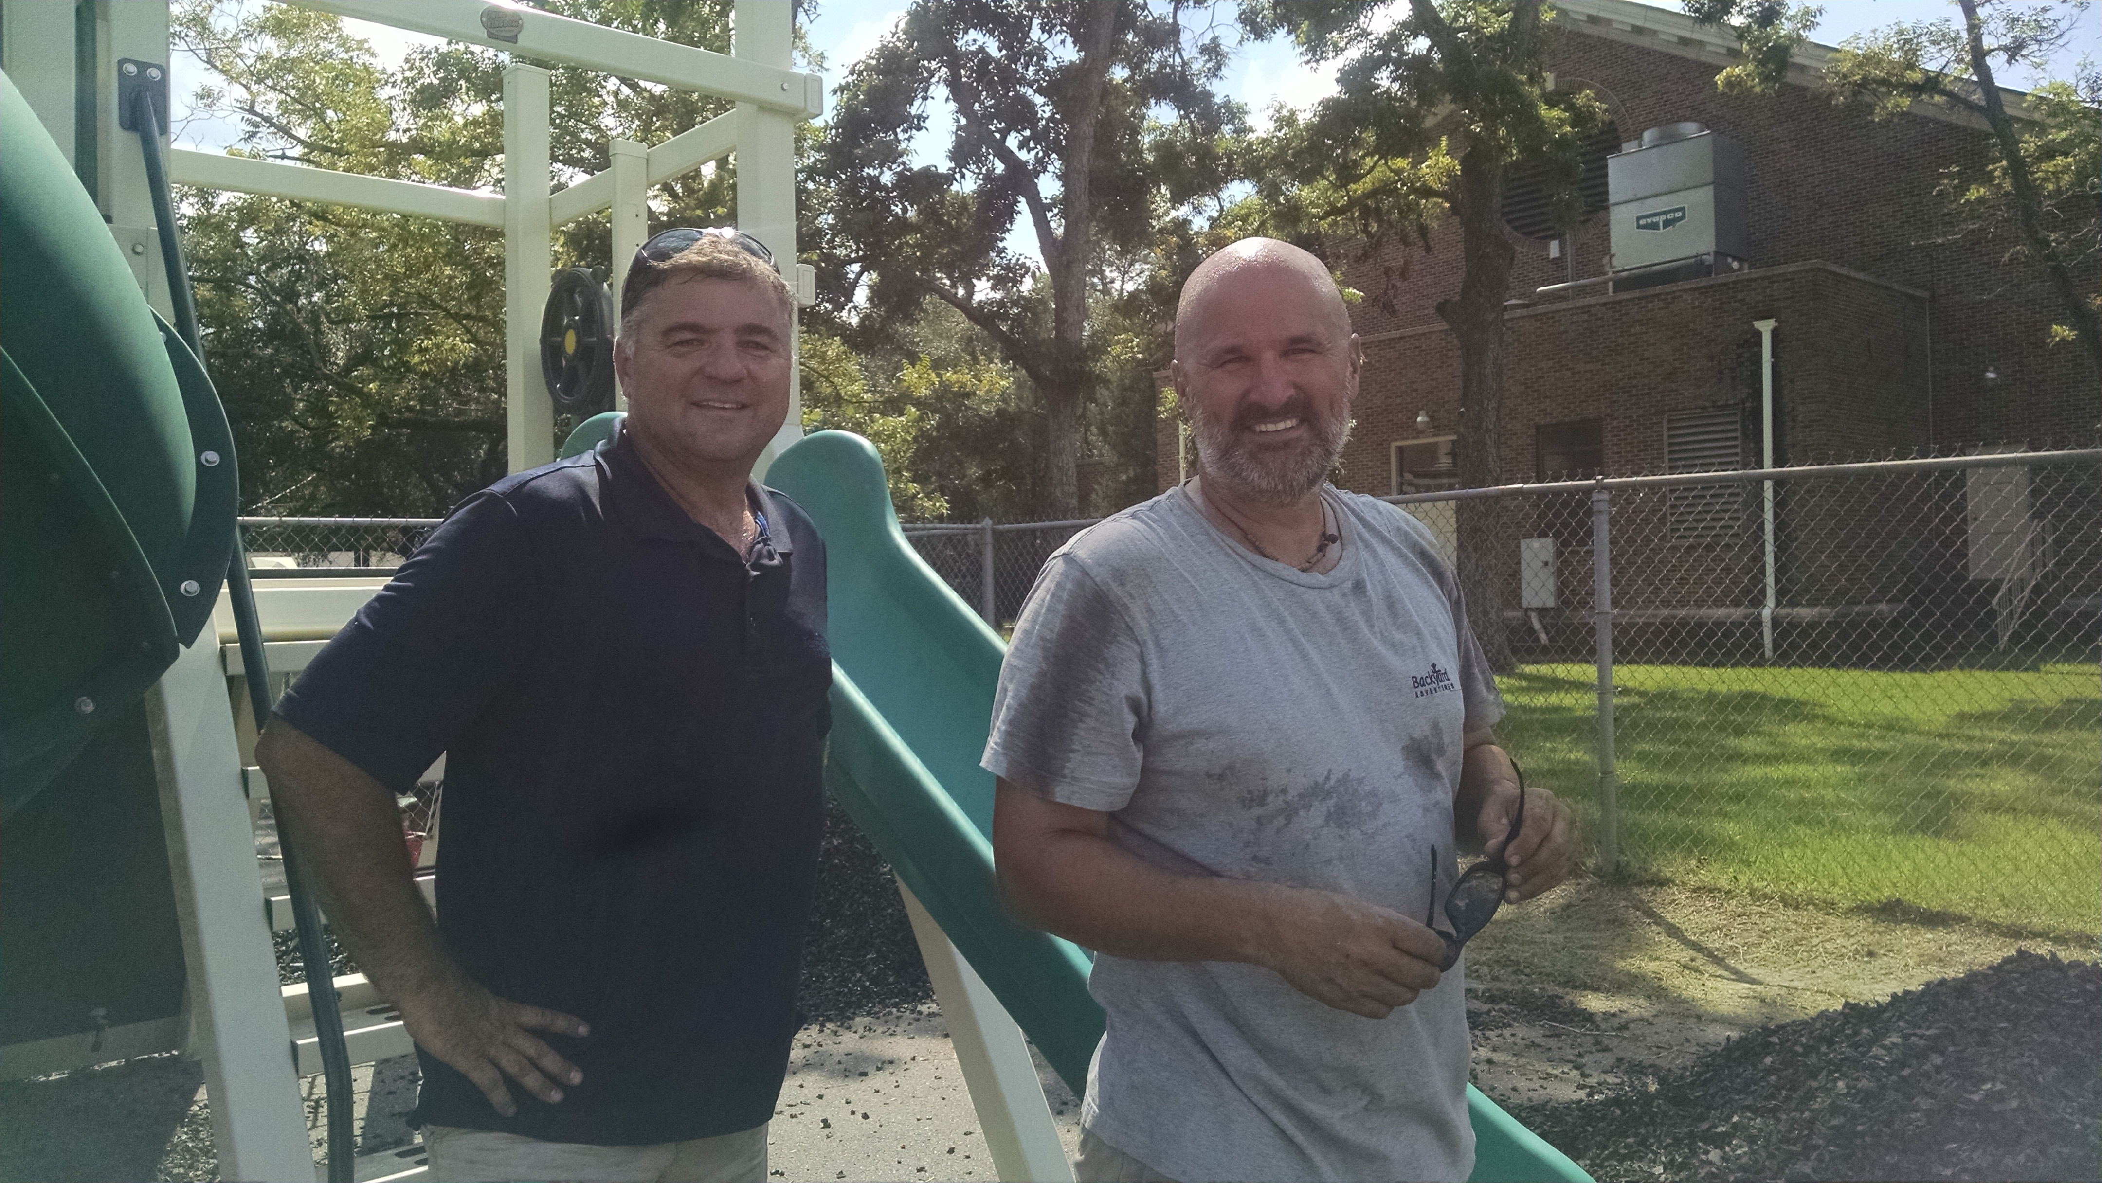

Thank you Backyard Adventures! Can not wait for Inaugural Playtime!

