OUTS
We collected donated items and service time this week:

Joyce Jackson and daughter Sara
(5,000 Community Coffee labels and New Donation of Ladies Pants)

Kindergarten and 5th grade
(Two new students began)
New 8th grader to start next week

Anonymous Donor to Diocese of Baton Rouge to Flood Victim Relief
($400.00 in Wal-Mart gift cards of $25)

Important Dates:
September | Praline Sales continue, $2.00 donation
 | Redemptorist Sock Sales, $5.00 donation
19 | ACT Aspire Interim Continues through Sept. 30
19 | Bus Emergency Unloading Drill, Dropoff @ 6:45am
20 | Principal Cohort Meeting, Ruth Oliver Principal On-Call
 | Speech Services begin by Ashley Hatfield, Title 1 room
23 | Send progress reports home
27 | 1st Dress Down Day for $1.00
30 | Employee Profiles and School File Updates Due
30 | 2nd Mass in the church
October 4 | Musical Performance by Sean Ardoin, 7:20am Assembly

iGive Catholic Campaign: Registration is now open for the donation program View iGive and prepare for the giving campaign November 29-30. Begin sharing with your families and spread the word! Questions? Contact tabshire@diobr.org

Song of the Week: (William McDowell) “I Give Myself Away”
“Here I am, here I stand, Lord my life is in your hands, Lord I’m longing to see your desires revealed in me.
I give myself away so you can use me. Take my heart, take my life as a living sacrifice. All my dreams, all my plans, Lord I place them in your hands. I give myself away I give myself away so you can use me. I belong to you. My life is does not belong to me My life is not my own, to You I belong, I give myself, I give myself to You.”

Scripture of the Week: I Timothy 2:4

Inspirational Pictures: THANK YOU FOR ALL THAT YOU DO FOR STUDENTS AND FAMILIES!

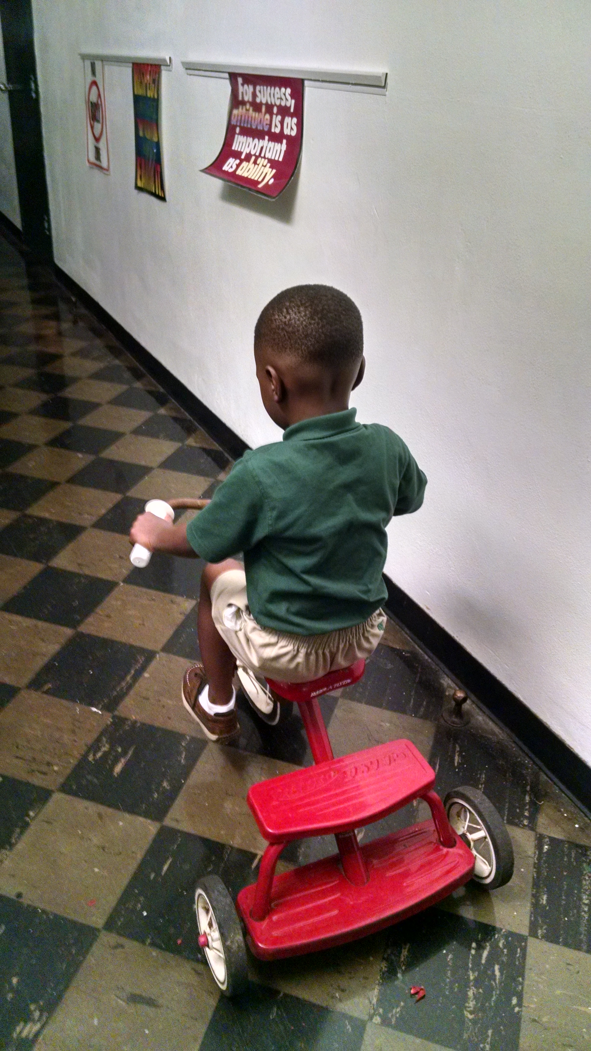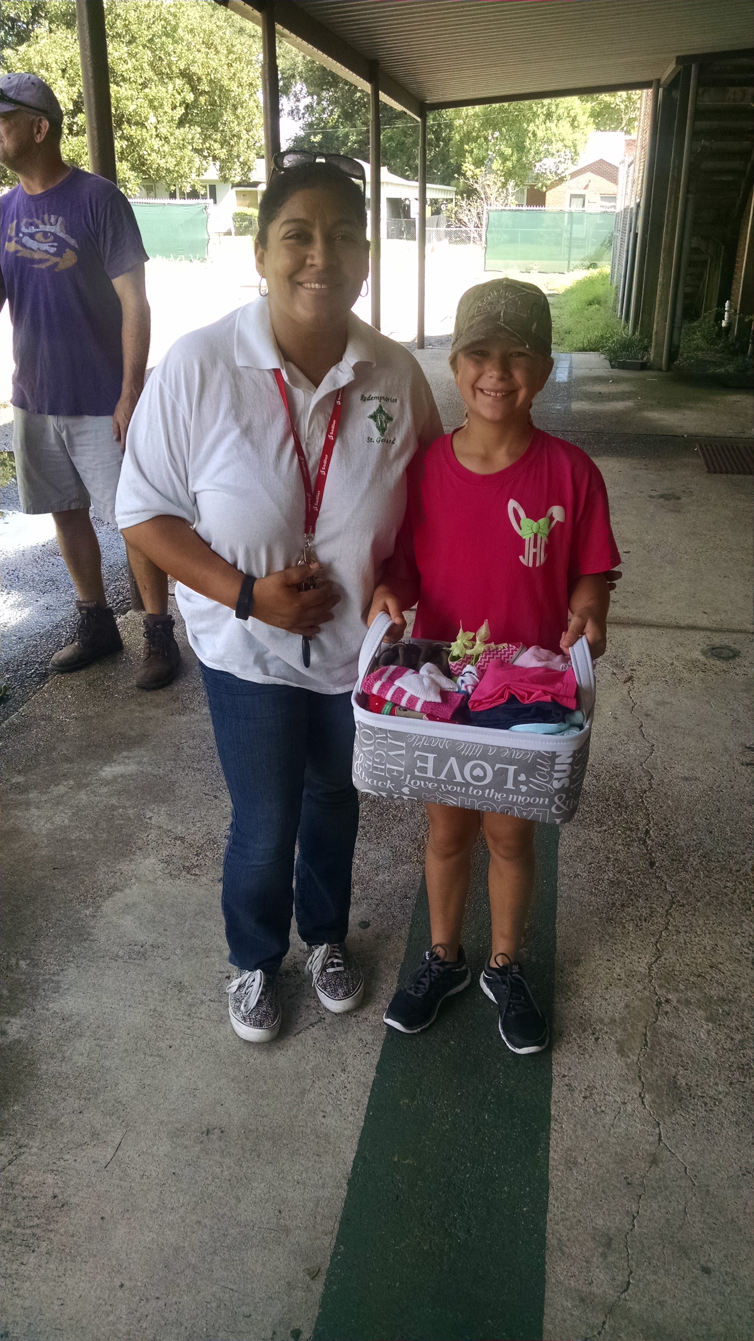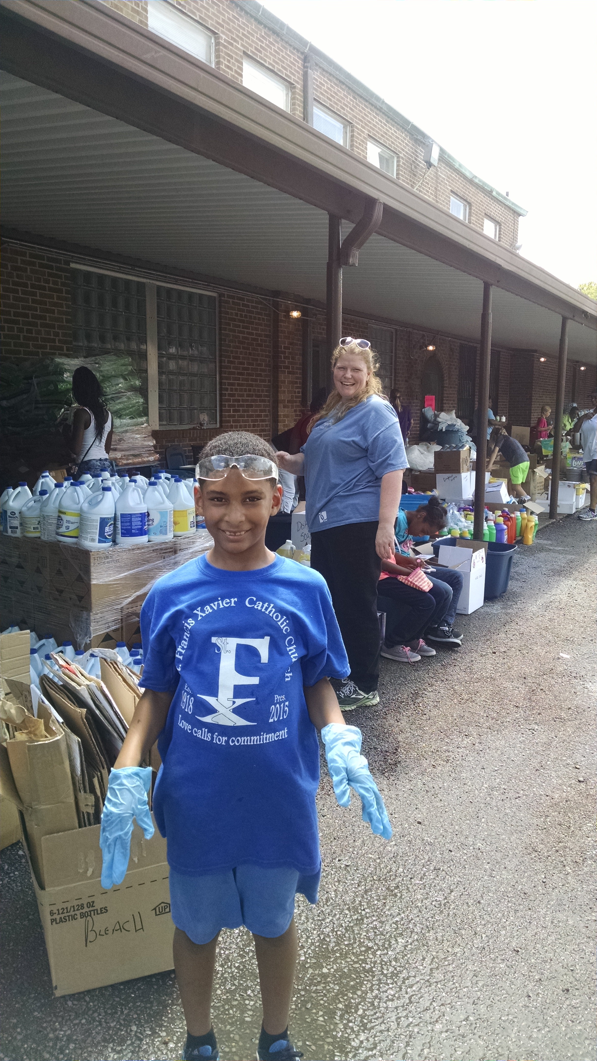
New white handlebars! Jenna and her gift basket! Cole and Stafford (Covalent Logic)

