OUTS
We collected donated items and service time this week:

Joyce Jackson
($1,000.00 toward next project)

Dr. Keith Courville, A+Pel
($1,000.00 toward next project)

Ruth Oliver
($50.00 toward Playground Initiative)

Mar. Marcus Spears and Mr. Adrian Ricard, Sr.
(Yardwork volunteer time and energy)

Coach Ron Parker and Principal Paula Johnson, St. Louis King of France
(5 used Smartboards)

Interact Club, The John Cooper School, Woodlands, Texas
(6 boxes of school supplies and bookbags)

Heston Family, Orlando, Florida
($25.00 assorted gift cards to Wal-Mart, Chick-fil-A, Target, Shell Gas, Exxon/Mobil gas)

Cheering4Books, Prairieville, Louisiana
(1,000 books for student home libraries)

Important Dates:
October | Redemptorist Sock Sales, $5.00 donation
3 | ACT Aspire interim extended through Oct. 7
 | Ms. Fontenot, substitute for Ms. Williams, begins
 | SBLC meeting with EBR for 7th grader, 7:30am, C. Barber
4 | Chip Miller working on principal-assigned computer projects
 | Faculty Meeting, 3:00pm, Computer Lab
5 | Discovery Walk by 5 Instructional Visitors, 8:00am - 1:00pm
6 | Sean Ardoin performs, 7:30 morning assembly
7 | First Flood Make-Up Day
 | Cancellation of Parent-Teacher Conferences

Song of the Week: (Kurt Carr) “I Almost Let Go”
“I almost let go. I felt like I just couldn’t take life anymore, my problems had me bound, depression weighed me down, but God held me close so I wouldn’t let go. God’s mercy kept me so I wouldn’t let go. I almost gave up. I almost gave up. I was right at the edge of a breakthrough but I couldn’t see it, the devil really had me, but Jesus came and grabbed me and he held me close so I wouldn’t let go. God’s mercy kept me so I wouldn’t let go.”

Scripture of the Week: 2 Timothy 1:6-8, 13-14

Inspirational Pictures: THANK YOU FOR ALL THAT YOU DO FOR STUDENTS AND FAMILIES!
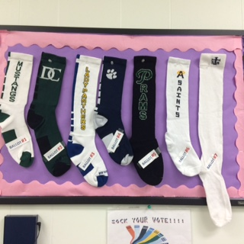
Share the right to vote with students. 7 sock designs and styles!
Cast your vote so I can order by Friday, October 7.
