Redemptorist Sweatshirt Sale 2017-2018
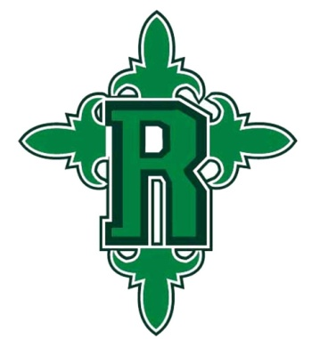

ALL sweatshirts are $25.00… CASH or MONEY ORDER ONLY
Please complete the order form below to purchase a school sweatshirt.
Return bottom portion with payment to school by THURSDAY, OCTOBER 5, 2017.
We are hoping to have another order in November in order to distribute them before Christmas Break.
Sweatshirts will be distributed for FULL PAYMENTS ONLY.
No sweatshirts will be distributed for partial payments.
Students are not permitted to wear any other sweatshirt. Only this sweatshirt meets uniform requirements!!!!
Redemptorist Sweatshirt Order Form 17-18
Student’s Name: ____________________________________________________
Homeroom Teacher’s Name: _______________________________ Grade: __________
Please mark the size(s) and number of sweatshirts per size that you would like to order: Y = Youth; A = Adult
_____ YXS _____ YXL _____ AS _____ AXXL
OFFICE USE ONLY:
Date Paid: _______________
Amount Paid: ____________
Date Fulfilled: ____________
_____ YS _____ AM _____ AXXXL
[Grab your reader’s attention with a great quote from the document or use this space to emphasize a key point. To place this text box anywhere on the page, just drag it.]
_____ YM _____ AL
_____ YL _____ AXL
AXXL or AXXXL will have an additional $3 charge.

